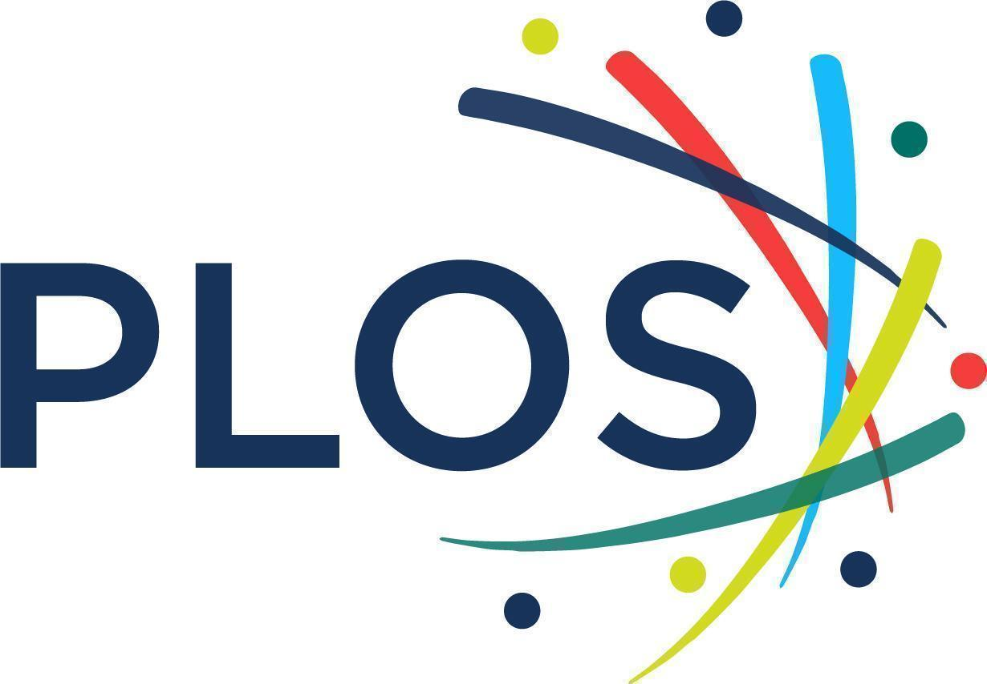

PLOS was created to drive change in scholarly publishing. To make the highest quality research openly available to every reader. To challenge subjective views of impact and let the transparency and rigor of the research process speak for itself. To reinvent policies, practices and business models in ways that reflect the true diversity of perspectives in science. We’re willing to break boundaries. www.plos.org

PLOS All Titles Offer for CRL, NERL and NERL Affiliates (NA) - Year 2 Opt in

Prepared by PLOS Partnerships team (partnerships@plos.org).
Proposal valid through November 15, 2022 for January 1, 2023 with option for “late joiners” February - July 2023.

PLOS Partnerships Team
Remote, based on the US East Coast
partnerships@plos.org

Thank you very much for your interest in partnering with PLOS. We’re eager to provide you with as much documentation as you need to make an informed decision about partnership. The following provides an overview of our journals, our models, what problems they’re trying to solve, how they’re structured, and fees.
Additionally, we want to underscore that your institution’s support pays for a variety of services for your authors including:
- Managing a global peer-review network of thousands of editors and reviewers across hundreds of disciplines
- Providing, maintaining, and updating the software and hardware to facilitate online-only peer-review
- Staffing a highly trained inhouse editors to manage the peer review process, handle author inquiries, support reviewers, and facilitate post-publication peer review
- Maintaining the complex network of systems and software that facilitate online-only digital journal production
- Broadly communicating the work of PLOS authors are publishing ensure maximum reach to the communities who can benefit most from access to that research
- Ensuring authors are engaged in open science best practices including sharing their data, using ORCiDs, the CrediT taxonomy and many other practices as part of our suite open science offerings
- Staffing an inhouse research team to better understand uptake of Open Science practices within and beyond PLOS
- Effectively resourcing a transformative approach to diversity, equity, and inclusion across our journals, business models, and business practices.
While not all of this work is reflected in our Plan S Price Transparency work (updated annually), it’s important to underscore how your institution is furthering the advancement of open science (not just open access).
Sara Rouhi, Director, Strategic Partnerships, PLOS
srouhi@plos.org

TABLE OF CONTENTS
⎮ WHAT PARTNERSHIP PAYS FOR 4
Partnership enables PLOS' mission 4
Furthering Open Science 4
Enabling online peer review via global networks 5
Facilitating online-only digital publishing operations and production 5
Ensuring equity of access and dissemination of research 6
⎮ PLOS AND OUR TITLES 6
The original inclusive, multidisciplinary megalith 6
Our highly selective journals 6
Our specialized community-led journals 7
Broad scope, quality driven titles - all new in 2022 7
Background on new titles 8
⎮LEADING BEST PRACTICES IN OPEN SCIENCE 8
Open access is just the beginning 8
2021 UNESCO Recommendation on Open Science 8
Overview of PLOS Open Science initiatives 9
Open Licenses 9
Open Data Policy 10
Published Peer Review 10
Preprints 11
CRediT and ORCiD 11
Sharing Methods including Code and Protocols 11
Preregistration 12
⎮PLOS BUSINESS MODELS OVERVIEW 12
Flat Fees for six titles (Including PLOS ONE) 12
PLOS Global Equity (GE) 13
PLOS Community Action Publishing (CAP) 13
⎮PLOS Business Model Summary 14
Executive Summary of PLOS/CRL/NERL/NA offer 16
Fee table for CRL/NERL/NA members 16
Overview of fee calculations 22
CRL/NERL/NA tiered fees: unlimited publishing in 12 titles 22
Fees by model/journal 24
Participation and FAQs 24
PLOS key contacts 26
Appendix 27

⎮ WHAT PARTNERSHIP PAYS FOR

Partnership enables PLOS' mission
As a nonprofit organization, PLOS does not seek revenue surplus purely for financial gain or as a return to shareholders. Our organizational activities are developed with the sole purpose of meeting the needs of researchers and reinvesting in the scholarly community to make all aspects of the research process open, transparent, and reusable for any community engaging in and with research.
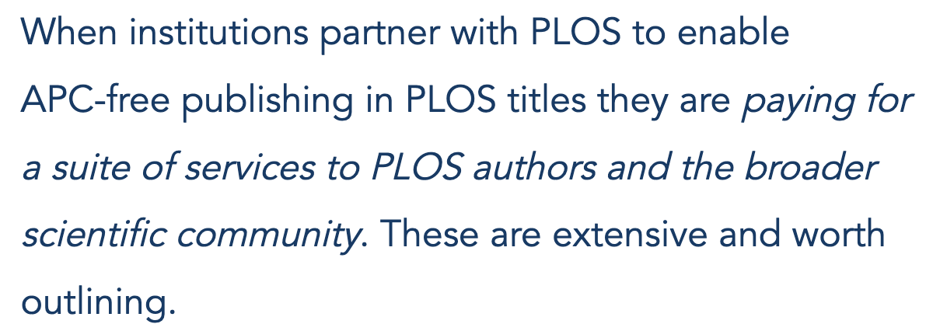

Furthering Open Science
As outlined in more depth below, we see Open Science as essential to enabling all researchers to contribute to, learn from, and accelerate scientific discovery. PLOS is committed to piloting, developing, and leading the way in establishing Open Science practices as community norms. . Open Science awareness, implementation, and uptake are critical components of making this mission a reality. This includes:
- A dedicated team of Open Science experts - PLOS’ Open Science research team is dedicated to understanding, implementing, and researching the uptake of Open Science behaviors across scholarly communication and especially within PLOS titles. They, along with PLOS’ Chief Scientific Officer, drive the Open Science practices embedded in all PLOS titles.
- Suite of 14 comprehensive Open Science Features across PLOS titles - Accelerating progress in research communication is only possible through Open Science best practices. PLOS has embedded a suite of core Open Sciences features across our titles to maximize uptake of these best practices. PLOS’ Open Science team develops and implements these features in collaboration with partners like Protocols.io, medRxiv, CredIT, ORCiD, and many other organizations.
- Open Science outreach and informational resources - PLOS engages researchers globally in discourse surrounding Open Science practices, to increase awareness and adoption of tools that increase research integrity, transparency, and reproducibility. PLOS staff create and maintain informational resources available on our website, promote Open Science practices through email and social media, and invite further discussion through participatory events such as Scientists 4 Open Science.

Enabling online peer review via global networks
We rely on the expertise of thousands of researchers spanning every discipline and corner of the globe to help us evaluate and shape the quality of everything we publish. Peer review networks, infrastructure, services, and support are foundational to PLOS’ commitment to ensure ethically and methodologically rigorous research is available as quickly as possible. This includes paying for:
Support and development of a global peer review network - PLOS manages and liaises with communities of thousands of editors and peer reviewers globally to ensure timely and rigorous peer review. PLOS employs several teams dedicated to providing robust support for this vast network of volunteers, including in-house editorial staff, journal managers, and research and recruitment specialists who ensure our editorial boards are staffed with appropriate expertise, and that volunteers receive the training and resources they need to make fair and objective decisions.
- Software and hardware to support peer review online - PLOS maintains both third party and homegrown technology to support a fully online peer-review process. Our editorial submission system, Editorial Manager (owned by Aries, now part of Elsevier), alone is a seven figure investment – essential to support a journal the size of PLOS ONE (to say nothing of our other titles!).
- Expert, highly trained PLOS staff editors and support teams - Managing editorial networks globally requires PLOS staff support from the US and UK to the Philippines. Online peer review requires the management of tens of thousands of author, editor, and peer-reviewer queries and technical checks across text, data, code, and other digital artifacts (to say nothing of extensive work of the non-PLOS peer reviewers themselves!). These teams are highly trained to ensure these processes are efficient, accurate, and fair to our communities.

Facilitating online-only digital publishing operations and production
- Dedicated team of ethics experts: Given PLOS’ high volume of publications and emphasis on ethical rigor, it is essential to have a dedicated, highly trained team focused entirely on ethical questions in PLOS research. The goal of this team is to ensure the integrity and validity of the research PLOS publishes, gathering and liaising with a complex set of stakeholders to fairly and transparently address ethical concerns. (Read more about their work here).
- Extensive system of software and infrastructure for digital journal production - Once research and other open science artifacts have made it through peer-review, making those objects openly available online requires technology and staff expertise to ensure an accurate version of record on PLOS’ site.. This work encompasses everything from indexing full text and metadata to various third parties and managing end-to-end XML workflow to ensuring corrections are handled correctly and ensuring technical checks are thorough and complete.

Ensuring equity of access and dissemination of research
- Global communication and dissemination of PLOS authors’ research - PLOS’ dedicated communications and outreach teams ensure that PLOS research receives global news coverage. More eyes on research ensures that society broadly is benefiting from the scientific process, making it easier for researchers and laypeople alike to access and understand peer-reviewed literature.
- Underpinning all this work is a comprehensive approach to Diversity, Equity, and Inclusion (DEI): PLOS has committed to be publicly accountable for a comprehensive strategy to ensure DEI is integrated into all aspects of its work. From composition of PLOS editorial boards and journal scopes to PLOS’ internal hiring and compensation practices, PLOS is dedicated considerable resources to both externally and internally focused foundational DEI work.

⎮ PLOS AND OUR TITLES

The original inclusive, multidisciplinary megalith
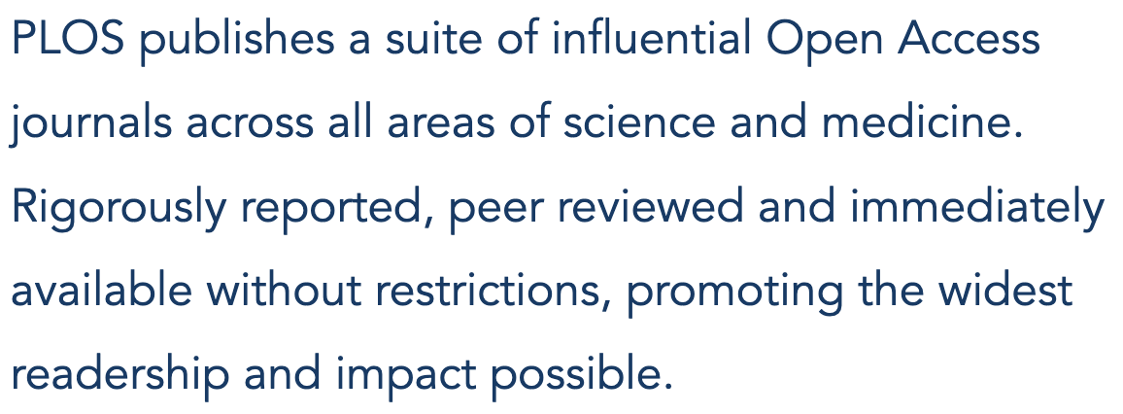
PLOS ONE publishes in over 200 subject areas across science, engineering, medicine and the related social sciences and humanities. Multidisciplinary and interdisciplinary research, negative and null results are all in scope.The journal was launched to subvert subjective views of research impact and ensure that all rigorous research could be published, widely accessible and discoverable.

Our highly selective journals
PLOS Biology publishes significant advances across the biological sciences. And we push boundaries.
Designed to advance science and the communities who depend upon it, we’re transforming research communication to fit the research process. Evolving article types and policies empower authors to share the full story behind their science with a global audience of researchers, educators, policy makers, patient advocacy groups, and the public.

PLOS Medicine publishes original research with the greatest potential impact on health and healthcare globally, making advances in the most important topics that face our society today available immediately, to every reader.

PLOS Sustainability and Transformation is a multidisciplinary forum for researchers to exchange knowledge and share leading research that drives critical progress in optimizing the use of renewable resources, transforming the global economy and achieving a sustainable future. NEW in 2022.

Our specialized community-led journals
At PLOS Genetics, we collaborate with researchers from every sub-field, career stage, and demographic to explore, share, and connect the varied complexities of genes and their impact on life in all organisms.
PLOS Pathogens explores the breadth and depth of pathogens research from authors across all disciplines, with publishing options for deeper context and transparency that show all the nuance of authors’ work while making it more widely accessible.

PLOS Computational Biology strives to break boundaries because we’re led by researchers with an appetite for change. We publish work that advances the biological sciences with trusted computational tools and techniques, and shapes the future of Open research communication.
PLOS Neglected Tropical Diseases brings global attention to the treatment and management of neglected diseases, and to the unique challenges faced by neglected communities against all diseases. We publish leading research from experts connected to the region, conditions, and culture of the people we aim to serve.

PLOS Digital Health publishes boundary-breaking research that uses digital tools, technologies, and data science to advance every aspect of health care. Open Science options at every stage of research communication empower researchers to drive trust, collaboration and reproducibility in this field. NEW in 2022.

Broad scope, quality driven titles - all new in 2022
PLOS Water brings together research of the highest methodological and ethical standards in the areas of water sanitation, resource recovery and use, applied water policy and the sustainable consumption, management and supply of water as a vital resource for societies in every region of the world.

PLOS Climate unites researchers across disciplines and regions of the world to tackle the causes and effects of climate change and dynamics at a global scale. Our goal is to empower global collaboration--between researchers and organizations, individuals and policymakers--that is centered around research of the highest methodological and ethical standards and the values of Open Science.

PLOS Global Public Health is a global forum for public health research of the highest ethical and methodological rigor that reaches across disciplines and regional boundaries to address some of the biggest health challenges and inequities facing our society today.

Background on new titles
In April 2021, PLOS launched five new titles as part of our new global strategy. Full details on the titles, their scope and their mission alignment are here: https://theplosblog.plos.org/2021/04/launching-new-journals-2021/

PLOS will be launching 5 new titles in 2023 in the areas of agriculture/agronomy, digital technology and innovation, mental health and well being, complex systems and population and aging. Any institution who opts into the PLOS offer will automatically have APC-free unlimited publishing and open science services thanks to this agreement.

⎮LEADING BEST PRACTICES IN OPEN SCIENCE
From increasing transparency at all stages of review to more inclusive models of assessment, PLOS is redefining how we evaluate, share, and read research: https://plos.org/open-science/

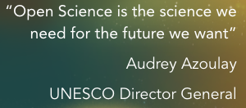
Open access is just the beginning
“Open” is about more than just being able to read or share an article. It’s about providing the right context to understand it. The resources to replicate it. The tools to collaborate and make science better. And building the framework for more equitable participation and distribution of knowledge.

2021 UNESCO Recommendation on Open Science
In 2019, UNESCO member states asked the organization to develop an international standard-setting instrument for Open Science to be adopted by member states in 2021. As stated on the UNESCO site, “The Recommendation was expected to define shared values and principles for Open Science, and identify concrete measures on Open Access and Open Data, with proposals to bring citizens closer to science and commitments to facilitate the production and dissemination of scientific knowledge around the world. The Recommendation was developed through a regionally balanced, multistakeholder, inclusive and transparent consultation process.”

The publicly available – and now officially adopted – recommendation lays the groundwork for an internationally shared standard for Open Science. PLOS Open Science work is deeply informed by this standard to ensure we are doing our part to “make multilingual scientific knowledge openly available, accessible and reusable for everyone, to increase scientific collaborations and sharing of information for the benefits of science and society, and to open the processes of scientific knowledge creation, evaluation and communication to societal actors beyond the traditional scientific community.”

Overview of PLOS Open Science initiatives
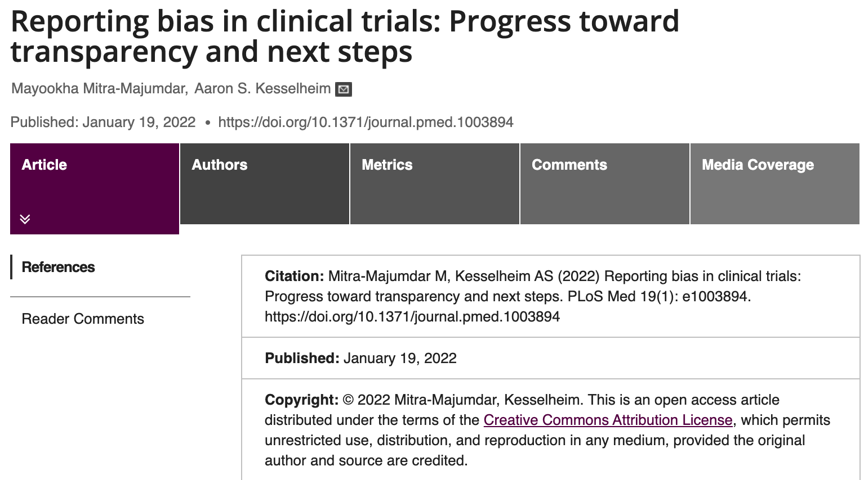
Open Science practices enrich the scientific record, extending the reach and maximizing the impact of research. Detailed documentation from the investigatory and peer review processes contextualizes research, sets an example for students, facilitates reanalysis and replication, and supports trust.
The following is an overview of PLOS’ suite of Open Science features.

Open Licenses
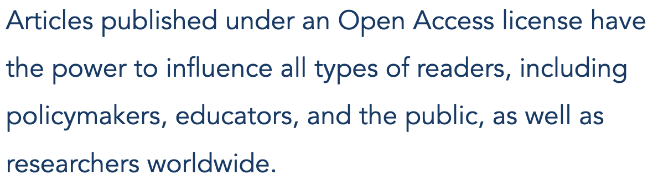
The Creative Commons-Attribution (CC BY) license balances the importance of scholarly credit, with the need to share research broadly and rapidly. Under a CC BY license, authors retain the copyright for their work while at the same time granting permission for anyone, anywhere in the world to read, share, reuse or remix the work for any purpose, as long as the original author is properly credited. Open licensing makes research accessible immediately upon publication, with no restrictions. Anyone with internet access can find, read, mine, cite and share OA articles at no cost to them.

All papers published with PLOS are automatically and immediately publicly available via CC BY license.

Open Data Policy
Open Data is a strategy for incorporating research data into the permanent scientific record by releasing it under an Open Access license. Whether data is deposited in a purpose-built repository or published as Supporting Information alongside a research article, Open Data practices ensure that data remains accessible and discoverable. For verification, replication, reuse, and enhanced understanding of research.

Publishing in a PLOS journal carries with it a commitment to make the data underlying the conclusions in your research article publicly available upon publication. Our data policy underscores the rigor of the research we publish, and gives readers a fuller understanding of each study.

Share more about the benefits of Open Date here: https://plos.org/open-science/open-data/#data
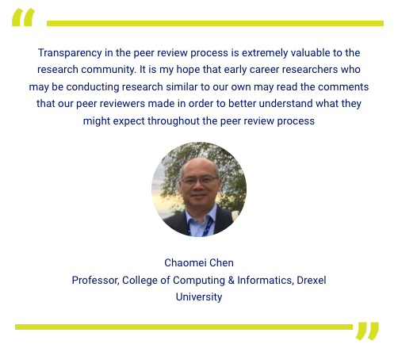

Published Peer Review
Our approach to open, published peer review encourages authors and reviewers to reveal the expert perspectives that help shape published research, promoting quality and accountability, and demonstrating the rigor of the peer review process.

At PLOS researchers decide what level of transparency is right for them. on a case by case basis. When a manuscript is accepted for publication at any PLOS journal, the authors can choose to release the complete Peer Review History alongside the final article under its own unique DOI, making it a part of the scientific record. The Peer Review History package collects the author correspondence exchanged during the peer review possess, including decision letters from each revision with both editorial feedback and peer reviews, and the authors’ responses to reviewers.

If the reviewers have chosen to sign, their names will appear alongside their comments. If not, the reviews will appear anonymously.

Learn more about the benefits of published peer review at the PLOS Blog here.

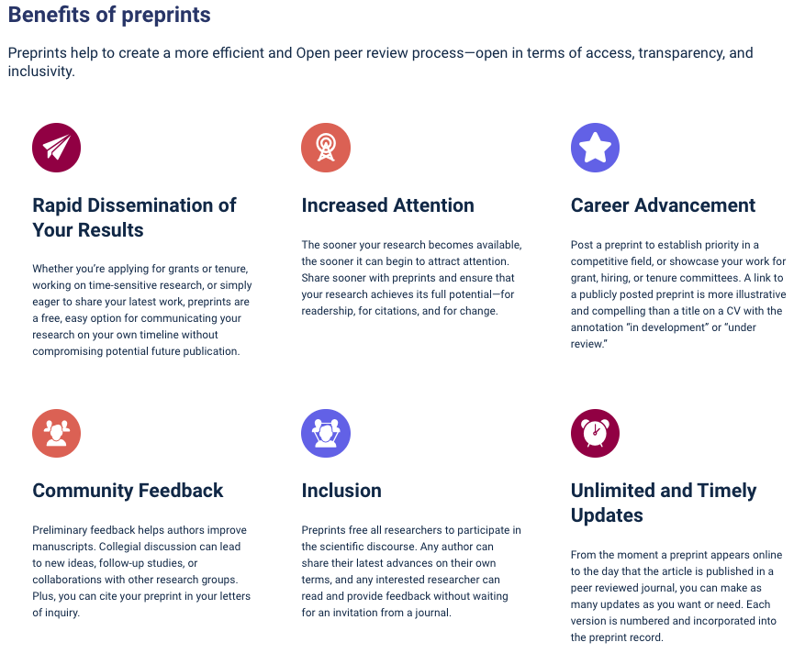
Preprints
PLOS encourages and enables posting of preprints for researchers to share, get feedback, and receive credit for their results sooner. Our partnerships make posting life sciences preprints easy and convenient.
- Direct Transfer from bioRxiv and medRxiv: Your authors can choose to have their preprints forwarded for consideration to the PLOS journal of your choice via Direct Transfer.
- Post to preprints servers during PLOS submission process: If your authors want to post a preprint to either bioRxiv or medRxiv, PLOS can do it for them. During initial submission, they just need to opt-in to have manuscripts posted on their behalf. They will appear on the site in less than 5 days.
- Post directly to the most relevant field-specific preprint server: Your authors can share the DOI to any specialized preprint server in which they deposit when they submit to a PLOS title.

CRediT and ORCiD
The CRediT taxonomy and ORCID empower authors and reviewers to claim credit for different kinds of research contributions with accuracy and granularity. How can we allocate credit fairly and accurately?
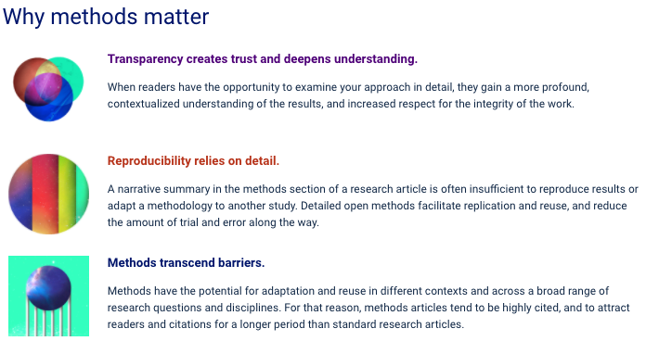
The challenges inherent in our current systems for assigning credit in scholarly communications fall into three major categories: identifying individual contributors, identifying their specific contributions, and recognizing contributions other than authorship. Open Science tools and practices offer thoughtful and evolving solutions for each of these credit challenges and recognize researchers for all of their scholarly outputs.

Sharing Methods including Code and Protocols
Open methods and raw data offer a glimpse at the framing of a research study. To generate conclusions, researchers make subjective decisions about how to analyze data and interpret the patterns they observe. The artifacts of research, such as detailed methods and raw data, are less likely to be influenced either positively or negatively by personal interests or opinion. That makes them less susceptible to publication or confirmation bias, which makes sharing essential. PLOS encourages all researchers to share methods (and requires all PLOS authors to share data).
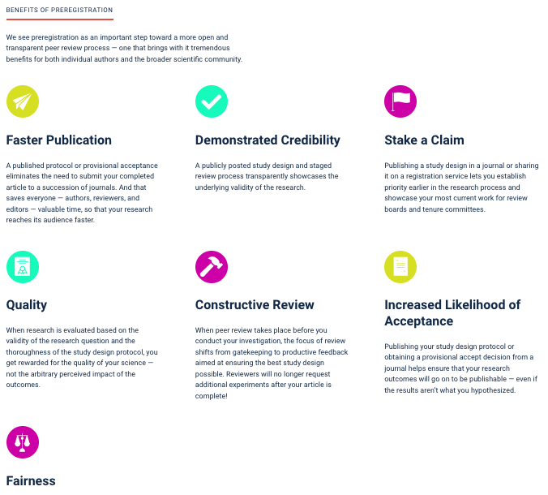

Preregistration
Preregistration is the practice of publishing a research question and study design with a registration service or journal before conducting a scientific investigation.

Preregistration enables research assessment to begin when science starts. Sharing research design also increases the credibility and reproducibility of results and helps address publication bias. Preregistration options are now available on PLOS ONE and PLOS Biology.

⎮PLOS BUSINESS MODELS OVERVIEW
While there are multiple approaches underpinning PLOS’ venture into non-APC based business models, the core experience for institutions and authors is the same: One annual fee for institutions and APC-free, unlimited publishing (pending peer review) for authors in the title(s) in question. Currently our business models are broken out by journals and payment mechanisms. Below is a brief description of the models and the journals to which they apply. New titles launched in 2021 are clearly indicated.

Flat Fees for six titles (Including PLOS ONE)
Institutions seeking uncapped, APC free publishing for their authors in the SIX APC-based titles (PLOS ONE, PLOS Computational Biology, PLOS Pathogens, PLOS Genetics, PLOS Neglected Tropical Diseases, and PLOS Digital Health - NEW) may elect to opt into “Flat Fees for the SIX.”

Fees for this model are calculated by looking at an institution’s historical publishing, APC-spend, and waiver rate in the existing PLOS titles (for corresponding authors), in addition to the current APCs at the time of negotiation. It also considers their anticipated publishing trend in PLOS Digital Health.
It also factors in a 4% per-article bulk discount, a growth assumption to pay for unlimited publishing, and the possibility of an “author transaction fee” to keep author grant monies as a funding stream to support publishing charges.

PLOS Global Equity (GE)
PLOS’ new broad-scope, inclusive titles - PLOS Water, PLOS Climate, and PLOS Global Public Health - have been launched to enable co-creation of paths to Open Science that work for diverse communities to build a more equitable global publishing landscape. These new journals create new and diverse communities of practice and ensure that they are at the forefront of shaping how we address the most pressing health and environmental issues facing our society.

To ensure that access to publishing in these titles is equitable, PLOS has developed our new Global Equity model empowering institutions in every region of the world to provide unlimited Open Access publication support for their authors through a single, annual fee that is affordable and equitably reflects regional economies.

Core components of this model:
- Historical publishing activity in the journal subject area from 2017-2020 (This is an indicator for publishing potential in the journal as there is currently little to no publishing history in the titles.)
- Counting affiliations of corresponding and contributing authors (as we do in the PLOS CAP model)
- World Bank Lending Classification: https://blogs.worldbank.org/opendata/new-world-bank-country-classifications-income-level-2020-2021
- Unique “equity contribution” option for institutions to further reduce the fees for L/LMIC institutions as a group

PLOS Community Action Publishing (CAP)
Winner of the ALPSP 2021 Innovation in Publishing Award, PLOS CAP is designed to make publishing in PLOS’ highly selective journals – PLOS Biology, PLOS Medicine, and PLOS Sustainability and Transformation – APC-free for institutions that become members. By equitably and transparently distributing the cost of publishing these titles amongst the institutions that publish in them the most, PLOS aims to prove that highly selective journals can be Open Access without prohibitively high APCs – or, indeed, any.

Institutions who pay an annual flat fee to join any of the three communities guarantee unlimited publishing for the corresponding authors in those titles with no fees, and a reduction in the article cost for contributing author papers. Authors from non-member institutions must pay a non-member fee to publish.
A deeper dive into how all models are calculated is available upon request: partnerships@plos.org

⎮PLOS Business Model Summary
Model | Applicable Journals | Basis for Fees | Discounts/notes
Flat Fees for the SIX | PLOS ONE  PLOS Genetics  PLOS Pathogens  PLOS Computational Biology  PLOS Neglected Tropical Diseases  PLOS Digital Health | Current list APCs,  institutions’ historic publishing trend in existing PLOS titles and in the subject area of digital health, institutions’ historic APC spend and waiver rates | Minimum 4% per article bulk discount that increases as publication volumes increase
PLOS Global Equity (GE) | PLOS Water  PLOS Climate  PLOS Global Public Health | Institutions’ historical publishing trends in the journals’ subject areas, contributing and corresponding author affiliations, World Bank lending class | Institutions may also consider an “equity contribution” to further reduce fees for L/LMIC institutions
PLOS Community Action Publishing (CAP) | PLOS Medicine  PLOS Biology  PLOS Sustainability and Transformation | Institutions’ historical publishing trends in the PLOS titles and the journal subject area of Sustainability and Transformation, contributing and corresponding author affiliations, publicly shared revenue and capped margin cost recovery target. Overages above revenue target are redistributed to community members through reduction of future fees. | PLOS Sustainability and Transformation  fees are reduced by 50% for early adopters.

Executive Summary of PLOS/CRL/NERL/NA offer

The current offer to CRL/NERL/NA members (with or without any existing agreements with PLOS) is for unlimited publishing and open science services in all 12 PLOS titles and the 5 new titles launching in 2023.

The offer itself is for all 12 titles. Should members prefer to pick and choose titles, PLOS is happy to work directly with you on a separate agreement.

YEAR 2 ALL TITLES PRICING

FEES FOR ONE YEAR | Annual Fee - All titles
Johns Hopkins University | $250,417
Harvard University | $238,508
University of Washington | $186,040
University of California, Davis | $155,309
Stanford University | $197,481
University of British Columbia | $157,482
University of Florida | $133,810
University of Minnesota | $136,795
Texas A&M University | $122,527
University of Pennsylvania | $135,445
University of California, Los Angeles | $133,040
University of Wisconsin–Madison | $129,497
Cornell University | $130,936
University of California, San Diego | $148,846
Duke University | $118,951
University of Pittsburgh | $117,386
University of Alberta | $99,045
University of Illinois at Urbana Champaign | $97,386
Columbia University | $146,145
University of California, Berkeley | $135,783
University of Michigan–Ann Arbor | $125,323
Emory University | $110,075
Washington University in St. Louis | $115,156
McGill University | $126,358
Boston University | $107,061
University of Southern California | $89,590
North Carolina State University | $75,118
Northwestern University | $94,600
University of Georgia | $73,640
University of Utah | $73,640
Rutgers, The State University of New Jersey | $72,541
Massachusetts Institute of Technology | $85,665
University of California, Irvine | $74,933
University of Ottawa | $75,920
Virginia Tech | $68,660
McMaster University | $68,460
Simon Fraser University | $69,296
University of Arizona | $73,645
Oregon State University | $62,721
University of Alabama at Birmingham | $67,472
University of Calgary | $66,486
University of Iowa | $60,859
Brown University | $62,980
University of Virginia | $61,109
Vanderbilt University | $65,985
Case Western Reserve University | $54,140
University of Göttingen | $51,634
The University of Texas at Austin | $70,139
Arizona State University | $52,505
Université Laval | $57,504
University of Kentucky | $54,916
University of Maryland, Baltimore | $48,737
University of Notre Dame | $47,954
Stony Brook University | $52,436
University of Connecticut | $53,358
University of Vermont | $46,881
University of California, Santa Barbara | $50,033
University of California, Santa Cruz | $45,809
University of Illinois at Chicago | $50,141
University of Missouri | $45,348
York University | $44,469
American University of Beirut | $34,930
Brigham Young University | $42,839
Northeastern University | $42,055
University of Manitoba | $43,001
University of Maryland, College Park | $44,244
Dartmouth College | $39,709
Kansas State University | $39,936
University of New Mexico | $39,709
University of Cincinnati | $39,771
University of Hong Kong | $44,989
University of South Florida | $41,139
Florida State University | $38,334
University of Nebraska–Lincoln | $37,795
University of Oregon | $42,908
University of Saskatchewan | $33,753
University of South Carolina | $29,600
George Mason University | $30,391
Georgia State University | $29,534
Temple University | $30,324
University of Delaware | $30,457
Texas Tech University | $27,977
University of Central Florida | $28,045
George Washington University | $33,266
Loyola University Chicago | $23,309
Miami University | $22,169
San Diego State University | $25,631
University of Maryland Center For Environmental Sciences | $22,169
Carleton University | $22,212
Concordia University | $22,212
Kent State University | $22,103
The University of Texas at San Antonio | $22,103
Boston College | $19,798
Florida International University | $20,939
Ohio University | $27,012
Ryerson University | $21,072
University of California, Merced | $19,757
University of Massachusetts Boston | $19,798
University of North Texas | $16,548
University of Oklahoma | $20,678
University of Victoria | $22,740
Ball State University | $16,270
Baylor University | $17,410
Binghamton University | $16,270
Brandeis University | $16,270
Lehigh University | $16,270
Trent University | $16,270
University of Maryland, Baltimore County | $15,130
Bowling Green State University | $12,784
Brock University | $14,707
Illinois Institute of Technology | $13,924
Macalester College | $9,363
Marquette University | $12,784
Northern Illinois University | $12,784
Smith College | $12,036
University of Dayton | $12,784
University of North Carolina at Greensboro | $15,106
University of North Florida | $12,784
The University of Texas at Dallas | $13,924
Sewanee: The University of the South | $10,503
Wilfrid Laurier University | $15,106
Ashland University | $7,017
Butler University | $7,017
Chicago State University | $7,017
Colgate University | $9,297
College of Wooster | $8,157
DePaul University | $10,437
Furman University | $7,017
The Graduate Center, CUNY | $7,017
Grinnell College | $7,017
Hamilton College | $7,017
Hampshire College | $7,017
Hope College | $7,017
Lafayette College | $8,157
Middlebury College | $7,017
Morgan State University | $9,297
Mount Holyoke College | $8,157
Norwich University | $7,017
Oberlin College | $8,157
Occidental College | $8,157
Towson University | $10,437
Union College | $7,017
United States Military Academy | $7,017
University of Alabama, Tuscaloosa | $13,858
University of Baltimore | $7,017
University of Denver | $10,479
University of Maryland Eastern Shore | $7,017
University of West Florida | $9,297
Valparaiso University | $7,017
Williams College | $8,218
Howard University | $9,298
Adler University | $5,918
Amherst College | $5,918
Bard College | $5,918
Baruch College | $8,218
Beloit College | $5,918
Berlin State Library | $5,918
Bowie State University | $5,918
Canisius College | $5,918
Carleton College | $5,918
Carthage College | $5,918
Colorado College | $7,068
Coppin State University | $5,918
Frostburg State University | $5,918
Illinois Wesleyan University | $5,918
Kalamazoo College | $5,918
Kenyon College | $5,918
Knox College | $5,918
Lake Forest College | $5,918
Lakehead University | $10,495
Liberty University | $5,918
Loyola-Notre Dame Library | $5,918
Millikin University | $5,918
Mount Allison University | $8,218
National Agricultural Library | $5,918
National Humanities Center | $5,918
Olivet Nazarene University | $5,918
Pepperdine University | $5,918
Queens University | $12,508
Rollins College | $5,918
St. Lawrence University | $5,918
St. Mary's College of Maryland | $5,918
St. Olaf College | $5,918
Salisbury University | $5,918
SUNY Geneseo | $5,918
Claremont Colleges | $9,368
New College of Florida | $5,918
Newberry Library | $5,918
School of the Art Institute of Chicago | $5,918
Thomas Jefferson Foundation | $5,918
University of Maryland Global Campus | $5,918
University of San Diego | $9,038
University of San Francisco | $9,368
Wofford College | $5,918

Fees by model/journal
PLOS Community Action Publishing titles - List fees (page 23 in public documentation) based on institutional publication corresponding and contributing author activity in PLOS titles from 2014 - Q3 2019 as outlined in our public documentation (page 19).

PLOS Global Equity titles - List fees (page 18 in public documentation) based on Web of Science corresponding and contributing author activity from 2016-2020 in the journal scope area as outlined in our public documentation (page 17).

PLOS Flat Fee titles (including PLOS ONE) - Flat fees for are calculated based on the following criteria (page 15 in our public documentation):

- Publication trends across five existing titles and in the journal scope of PLOS Digital Health (data from Web of Science from 2016-2020)
- Average of 2019-2020 publications, spend, and waiver rates for the existing five journals
- Current APC rates for the six titles
- A three year growth assumption required to make unlimited publishing sustainable (this growth assumption decreases the more institutions participate in the offer).
- Minimum 4% per-article bulk discount (that increases as publishing volume increases)
- An additional 2% savings on the Flat Fee portion of the deal given the participation rate in year 1 of the deal.

Participation and FAQs
Deal term: Approximately 2 years depending on your institution’s start date with all deals ending December 31, 2024

Start dates: October 1, 2022 (2.25 yrs), January 3, 2023 (2 years), April 1, 2023 (1.75 yrs), July 1, 2023 (1.5 years)

Commitment deadlines: 1 September (for Oct 1, 2022); 15 November (for Jan 3, 2023), 28 Feb 2023 (for April 1, 2023), 1 June 2023 (for July 1, 2023)
Proration for off-year starts dates: Institutions that join before or after the Year 1 start date (Jan 3, 2023) will have their fees prorated for the Global Equity and Flat Fee models. CAP titles are NOT prorated because the model is built as a collective and changes in one institution’s fees affect all other members. PLOS is happy to check the submission pipeline to see if you have papers likely to be accepted after your institution’s chosen start date.

Offer eligibility: Corresponding authors currently from an institution that has opted into the agreement, who are currently enrolled/working at the institution and have an institutional email address whose papers are accepted on or after the agreement start date.

Eligibility verification: Institutions will receive a Monthly Accepted Manuscript (MAM) report (as an Excel spreadsheet) listing the complete author and article metadata (including DOIs) for all papers accepted in the last month. Institutions have 14 days to review this list if they wish – review is NOT required – to verify that authors who have opted in are actually eligible for the agreement. If there are errors, the institution will notify partnerships@plos.org and any author who is NOT eligible will receive an invoice. Their paper will not be associated with the agreement and this correction will be reflected in the next MAM report.

Author workflow to participate: Currently, Canadian authors wishing to benefit from their institutions’ participation in this offer must follow the delineated workflow outlined in our author instruction guides: For PLOS Biology, Medicine, and Sustainability and Transformation, and the other nine PLOS titles. While PLOS has two billing systems, these instructions will remain distinct based on the journal to which an author is submitting. We aim to have a unified billing system for all 12 titles implemented in the second half of 2023.

Marketing support to communicate the benefits: PLOS has a dedicated “kick off” with institutions 4-6 weeks before their agreements go live to ensure we are aligned on how we support reporting, eligibility, and author communication. One tool we provide is our “Librarian Welcome Pack” which provides a comprehensive set of marketing and communication tools to support the library’s outreach efforts. We encourage feedback on what other tools/support libraries need to get the word out.

Journals/OS services | Model | Term period | Eligibility | About fees | Notes
All 12 PLOS titles, all available OS services | CAP + GE + Flat Fee | January 3, 2023 - 31 December 2024 (with optional alternative start dates) | Corresponding authors ACCEPTED after start date | - Invoicing and agreement through CRL/NERL/NA  - S&T fees are discounted 50% for anyone joining between 2022-2024  - Flat Fee titles include a 4% per article discount  - 5% set-up fee in year one is to cover the set up fees for multiple billing solutions as PLOS moves away from its current infrastructure to a unified solution in 2023. All institutions commencing new deals in 2023 are subject to this fee, which has been discounted for CRL/NERL/NA. | Any institution with an existing PLOS agreement may modify to participate in this agreement. Institutions who already have CAP or GE titles will have those fees “grandmothered” into this agreement.

PLOS key contacts
PLOS Partnerships team - US, east-coast based (GMT- 5 hours) 8:30 am - 6 pm M-Fr at partnerships@plos.org
Sara Rouhi, Director of Strategic Partnerships, srouhi@plos.org, +1 202 505 0814

Appendix
PLOS current APC rates and Non-Member Fees as of August 2022 (These increase annually)
https://plos.org/publish/fees/
JOURNAL* | APC (reflected in USD)
PLOS ONE | $1,805 USD
PLOS ONE Registered Report Article | $800 USD
PLOS ONE Registered Report Protocols | $1,380 USD
PLOS ONE Lab Protocols & Study Protocols | $1,805 USD
PLOS GENETICS | $2,655 USD
PLOS PATHOGENS | $2,655 USD
PLOS COMPUTATIONAL BIOLOGY | $2,655 USD
PLOS NEGLECTED TROPICAL DISEASES | $2,495 USD
PLOS CLIMATE | $2,100 USD
PLOS WATER | $2,100 USD
PLOS GLOBAL PUBLIC HEALTH | $2,100 USD
PLOS DIGITAL HEALTH | $2,575 USD

PLOS CAP TITLES | NON-MEMBER FEES 2022
PLOS MEDICINE | $5,300 USD
PLOS BIOLOGY | $5,300 USD
PLOS BIOLOGY Discovery Report | $4,500 USD
PLOS BIOLOGY Update Articles | $3,000 USD
PLOS SUSTAINABILITY AND TRANSFORMATION | $3,000 USD
Complete overview of PLOS’ publication fees can be found at https://plos.org/publish/fees/

The exception to this methodology is PLOS Sustainability & Transformation because it is a new title in 2022 and has no publishing history. For this title we looked at the 2016-2020 corresponding and contributing author activity in the journal scope area as a proxy. We will shift to journal publishing actuals when we re-tier institutions in 2023.

