

**Digital Archive Subscription Information**

*The HistoryMakers Digital Archive* is a unique, reference tool that provides easy access to an internationally recognized archival collection of thousands of African American video oral history interviews that are part of *The HistoryMakers* Collection. *The HistoryMakers*, the nation’s largest African American video oral history archive is the only methodic and wide-scale attempt to capture the personal testimonies of African Americans since the 1930s Works Progress Administration’s (WPA) recording of former slaves.

**Content**

*The HistoryMakers Digital Archive* includes interviews of both well-known and unsung African Americans including President Barack Obama (when he was an Illinois State Senator), Harry Belafonte, Ossie Davis & Ruby Dee, B.B. King and 211 interviews with the nation’s top African American scientists.  The earliest recollection recalls family history hearkening back to the 1700s. With interviews from over 180 U.S. cities and towns as well as from the Caribbean, Mexico and Norway, *The HIstoryMakers'* collection represents a rich but far-flung network of historical connections that are easily searchable by image, text and thematic references. This premier online educational tool with unique primary source material consists of:

* Unlimited access to nearly 3000 hours of digitized, streaming video interviews. This will continue to grow.
* Unlimited access to nearly 50,000 story segments and full length interviews
* Access to more than 2,700 HistoryMaker biographies via www.thehistorymakers.com
* Searchable keyword, index, tag, facet and browsing terms
* Career and reference sources
* Leadership, role models and mentors to today’s youth
* Unique material unavailable anywhere else

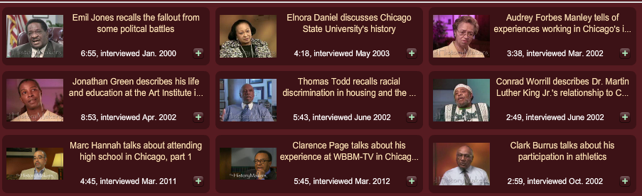

Figure 1: Search Results

**Access Points for Research and Discovery**

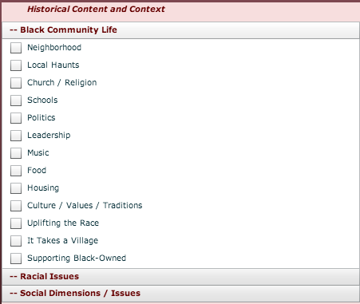*The HistoryMakers Digital Archive* is suitable for everyone from scholars to students beginning to explore the field and supports research, teaching, and student projects in Black Studies and many other disciplines that benefit from a first person account of the black experience including civics, business, art, law, science, medicine, education, media, music, entertainment, military, politics, religion, sports and even fashion and beauty! *The HistoryMakers Digital Archive* has been designed to support the following search capabilities:

Figure 2: Tag Samples

**Browsing:** Table of contents provides access to full interviews

**Text Searching:** Search full transcripts by keyword and get results narrowed down to the story level Instantly find specific content.

**Search In Search (Cross Searching):** Narrow text search results by additional key word text searching capabilities.

**Faceted Searching:** Faceted searching by gender, year, job type and category.

**Tag Searching:** Searchability by themes including ethics, faith, racial issues, personality, and black community life**.** Story segments divided by “Great Story”, “Historically Significant” and “Captures Personality”

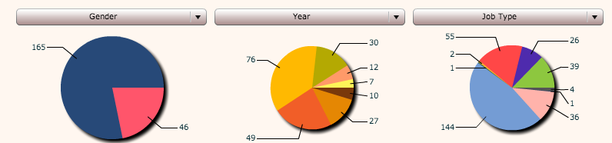

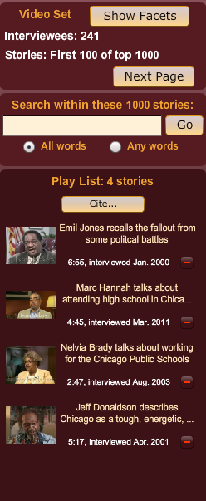Figure 4: Faceted Searching

Figure 4: Customized Toolbar

**Functionality for scholarship and classroom use**

* Thousands of interviews of contemporary African Americans who have broken barriers or accomplished significant achievements. Each video is two to three hours in length, fully subject-indexed and accompanied by transcripts Synchronized, searchable transcripts run alongside each video.
* Digital resource of primary sources, objective fact and subjective context
* Quickly scan each interview for its contents by easy viewing.
* URLs provides for easy citing and sharing of video.
* Users can organize, annotate, create and save clips under their own playlist.
* In-class, on-campus, and remote-access viewing permissions included.

**Technical Specifications/** **Publication details**

* The collection features *The HistoryMakers Digital Archive* enhanced video player that includes variable bit streaming up to 2.5 mbps, and expanded embedded video capability.
* Full Text transcript displayed with video player.
* No special setup or software is required—all you need is an Internet browser. For more information, or to request a trial or price quote, please email [info@thehistorymakers.com](mailto:info@thehistorymakers.com).
* *The HistoryMakers Digital Archive*  is an online collection available to academic, public, and school libraries worldwide via annual subscription.

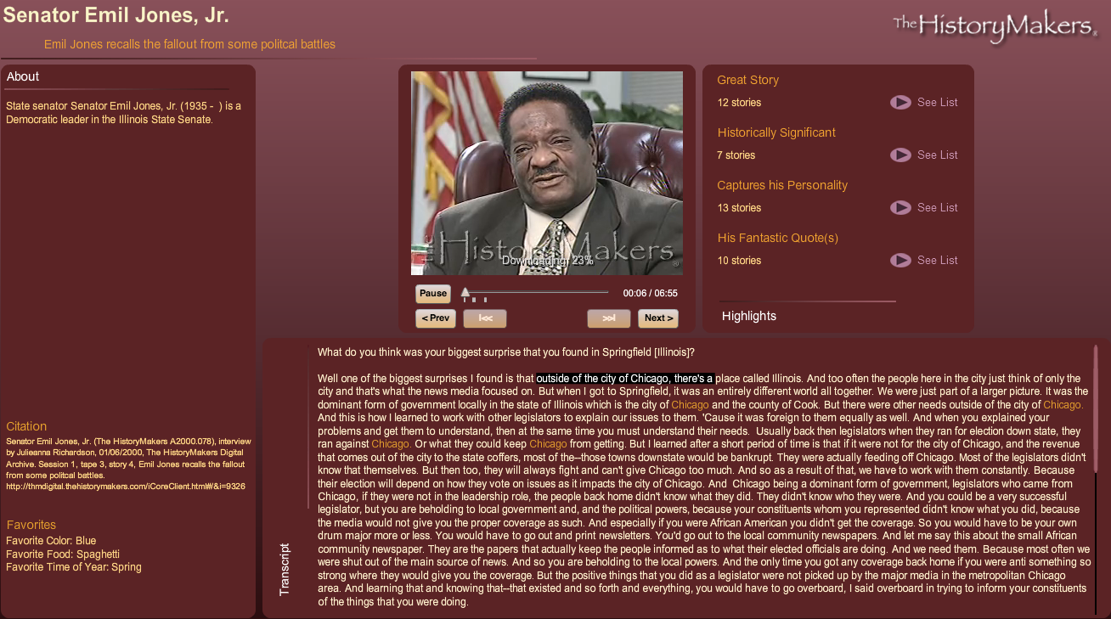

Figure 5: Video Player Screen

**Copyright Information**

*The HistoryMakers Digital Archive* of digital images and interviews is owned and operated by *The HistoryMakers.* All of the content featured or displayed in *The HistoryMakers Digital Archive*, including, but not limited to, text, graphics, photographs, images, moving images, and sound ("CONTENT"), is owned by *The HistoryMakers*, or its licensors and content providers. All elements of *The HistoryMakers Digital Archive,* including, but not limited to, the general design and the CONTENT, are protected by copyright, moral rights, trademark and other laws relating to intellectual property rights. NO portion or element of *The HistoryMakers Digital Archive* or its CONTENT may be copied, downloaded, or retransmitted via any means and *The HistoryMakers Digital Archive*, its CONTENT and all related rights shall remain the exclusive property of *The HistoryMakers* or its licensors unless otherwise expressly agreed. Individuals or organizations must apply for, and obtain written permission from *The HistoryMakers* to republish, or use any part of *The HistoryMakers* ' work. In applying for such permission, the user will be required to describe the purpose of the work, the extent of the use, and the form in which it will appear.

**The HistoryMakersTest Site**

*The HistoryMakers Digital Archive* was launched on test basis in May of 2010 and 5,000 users worldwide registered.

* 50% of the users had a graduate degree
* Users came from 51 countries around the globe including Afghanistan, China, Columbia,Denmark, Haiti India, Norway, Nigeria and Taiwan.
* 60% of users were African American and 40% Caucasion and others.

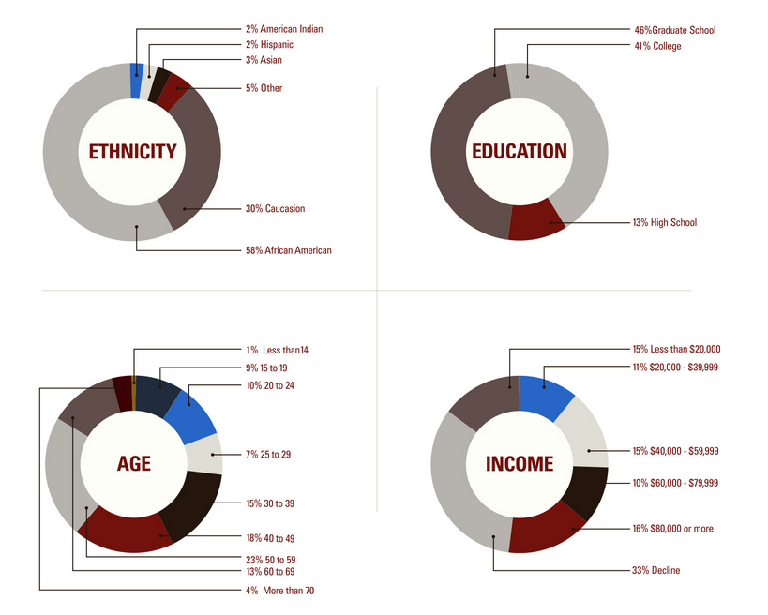

Figure 6: Test User Stats